Project Design Phase-II
Technology Stack (Architecture & Stack)
Date | 07 October 2026
Team ID | Service Now
Project Name | Diagnostic Test Center Portal
Maximum Marks | 4 Marks
Technical Architecture:
The deliverable includes the architectural diagram below and the information as per Table-1 and Table-2.
Example: Online diagnostic test booking and report management on ServiceNow
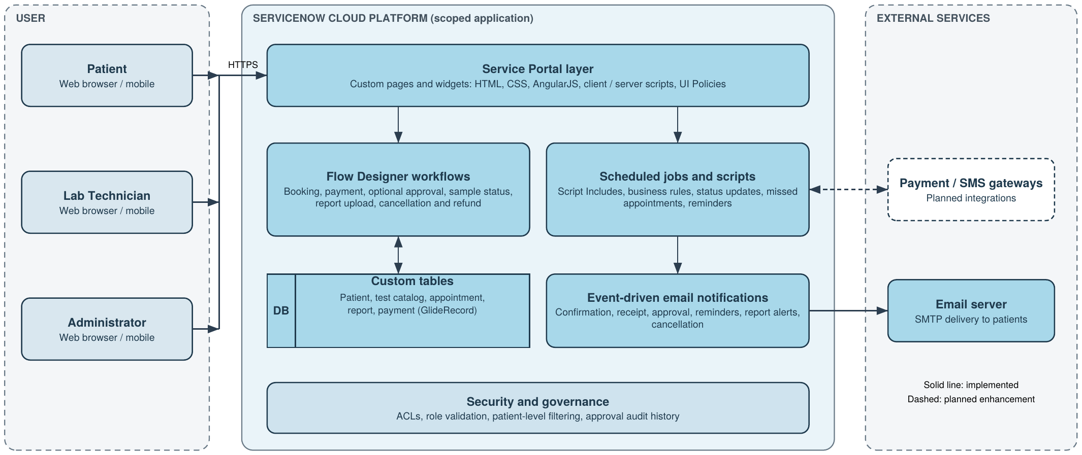
Architecture notes:
- Processes: portal booking, slot validation and pricing, Flow Designer workflow with approvals, scheduled jobs and notifications are shown as application logic blocks.
- Infrastructure: the whole solution runs in the ServiceNow cloud; users access it through a browser (no local server).
- External interfaces: email server today; payment and SMS gateways planned (dashed).
- Data storage: custom ServiceNow tables with attachments for reports. Machine learning model: not applicable.

Table-1 : Components & Technologies:
S.No | Component | Description | Technology
1 | User Interface | Service Portal pages and custom widgets for test selection, slot availability, booking summary and cost, appointment tracking and report download; UI Policies and client scripts control dynamic form behavior. | HTML, CSS, AngularJS, Client / Server Scripts, UI Policies
2 | Application Logic-1 | Booking and slot logic: validates slot availability, prevents overlapping appointments and auto-calculates test charges. | Flow Designer, Script Includes, GlideRecord (server scripts)
3 | Application Logic-2 | Payment, approval and cancellation logic: payment confirmation, role-based approvals (Admin / Lab Manager), conditional approval for high-value tests, cancellation penalties and refund handling. | Flow Designer, scripted actions, Approvals
4 | Application Logic-3 | Automation and communication: scheduled jobs update status after report upload, mark missed appointments and send reminders; event-driven emails for confirmations, receipts and report alerts. | Scheduled Jobs, Events, Notifications, dynamic email scripts
5 | Database | Custom tables for patient details, diagnostic test catalog, appointments, reports and payment transactions. Relationships: Patient to Appointment (one-to-many), Appointment to Report (one-to-one), Appointment to Diagnostic Test (many-to-one). | ServiceNow custom tables, reference fields, GlideRecord
6 | Cloud Database | Tables are hosted in the database of the ServiceNow cloud instance; no separate database server is managed. | ServiceNow Cloud instance database
7 | File Storage | Diagnostic reports uploaded by lab technicians are attached to report records and downloaded by patients through the portal. | ServiceNow attachments (platform storage)
8 | External API-1 | Email delivery of appointment confirmation, payment receipt, approval updates, reminders, report alerts and cancellation notices. | Email notifications (SMTP email service)
9 | External API-2 | Planned integration with external payment gateways and SMS notifications (future enhancement). | Payment gateway API, SMS gateway (planned)
10 | Machine Learning Model | Not used in the current version; analytics expansion is planned for the future. | Not applicable
11 | Infrastructure (Server / Cloud) | Scoped application deployed on the ServiceNow cloud platform. Local server configuration: not required, access is through a web browser. Cloud server configuration: ServiceNow instance hosting portal, workflows, tables and jobs. | ServiceNow Cloud, scoped application

Table-2: Application Characteristics:
S.No | Characteristics | Description | Technology
1 | Open-Source Frameworks | Front-end widgets are built on frameworks bundled with Service Portal. | AngularJS, Bootstrap
2 | Security Implementations | ACL rules restrict read, write, create and delete access, report upload and payment modification; role validation in widget server scripts; patient-level filtering so users see only their own appointments and reports; sensitive patient and payment data protected in line with healthcare privacy standards; approval audit history. | ServiceNow ACLs, roles, Debug Security Rules
3 | Scalable Architecture | Three-tier design (Service Portal, logic layer, data layer) built as a scoped application with modular widgets, reusable Script Includes, configurable Flow Designer actions and structured table relationships; ready for payment gateway, SMS, doctor portal and analytics extensions. | Service Portal, Flow Designer, Script Includes, scoped app
4 | Availability | Runs on the managed ServiceNow cloud platform; background jobs run on a schedule; Flow Execution Details and system logs help detect and fix failed actions quickly. | ServiceNow Cloud, Flow Execution Details, System Logs
5 | Performance | Server-side GlideRecord queries, real-time slot validation, reusable components and minimal hardcoding; reminders and status updates run as background jobs so users are not delayed. | GlideRecord, Scheduled Jobs, Service Portal preview tools
Monitoring and Maintainability:
- Monitoring: Flow Execution Details, System Logs, gs.info() debugging, GlideRecord trace analysis, Service Portal preview and Debug Security Rules validate data flow, automation triggers and role-based access.
- Best practices: scoped application development, proper naming conventions, role-based security design, minimal hardcoding and structured table relationships.
References:
https://developer.servicenow.com/
https://c4model.com/
https://www.ibm.com/cloud/architecture
https://aws.amazon.com/architecture

